Python_Problem_Statement _4_Anup_Patil

**Write a Python program to reverse a string.**

﻿Sample String : "1234abcd"

Expected Output : "dcba4321"

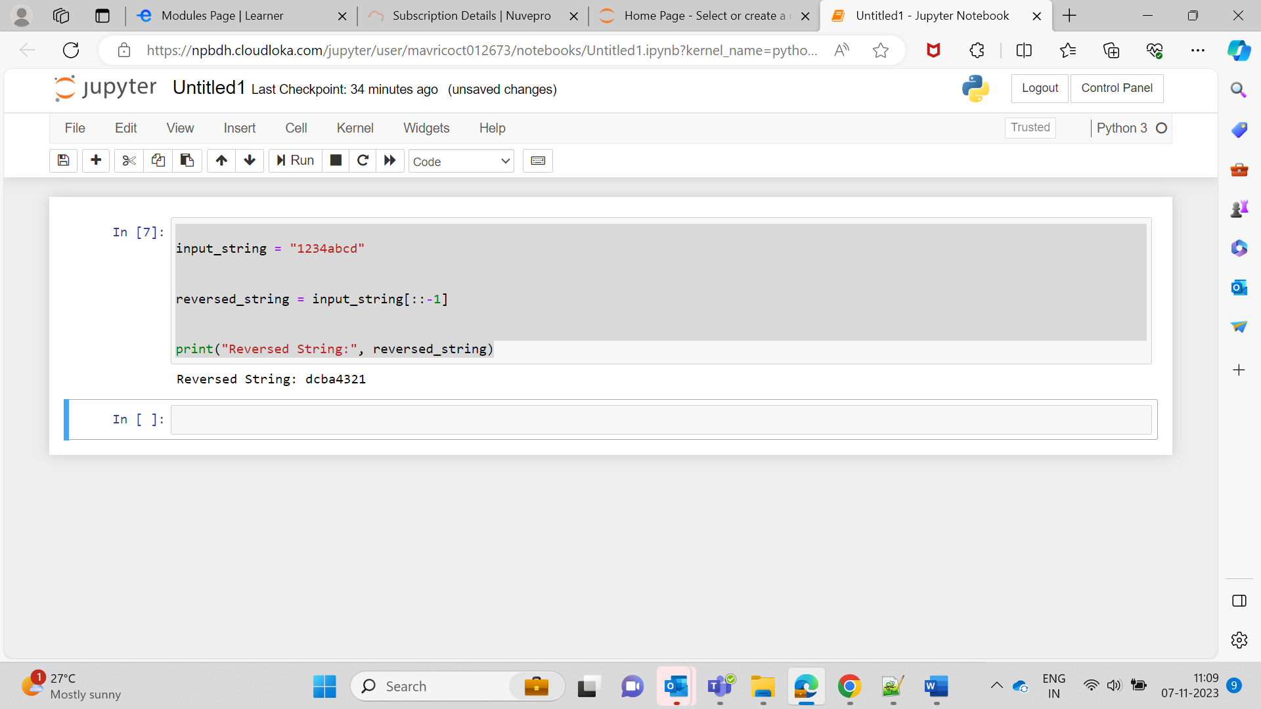

input_string = "1234abcd"

# Reverse the string using slicing

reversed_string = input_string[::-1]

print("Reversed String:", reversed_string)